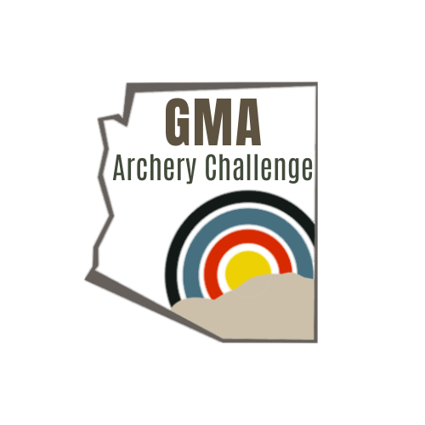

One continuous course consisting of 30 targets. Targets present challenging, technical, and distance.

No crossbows permitted. Field tips only, no broadheads.

**Fun Shoot:**

$30 Adult or $45 family

Fun shooters may shoot from any chosen distance, the target marker or closer. Shooters are not permitted to shoot distances greater than the target marker for safety reasons.

**Competition:**

$35 fee to compete.

Known Yardage – must provide own rangefinder.

Shoot based on the honor policy. Minimum, two shooters per group. All shooters begin the competition at target #1 and progress through the course, to the last target. Shoot at your leisure. You may exit the course and return to the target where you left, to complete the remainder of the course. 1 arrow per target, scored 5,8,10, and 12. Hooves, horns, and decoration score as a miss.

Classes:

***Fixed Pin Male-number stake Fixed Pin Female- Pink Whisker***

Fixed pins, no limit on pins. If you are running a slider, you cannot slide or adjust once you enter the course. If you need to slide or adjust your sight for a greater distance, you must shoot the open class. No stabilizer restrictions.

***Open Male-number stake Open Female-pink whisker***

No equipment restrictions

Score cards:

Score cards must have a running total, total number of 12’s, signed and initialed by score keeper. No single shooters permitted on the course. You must be accompanied by another shooter or a spectator, this is for scoring reasons as well as safety.

Score cards must be turned in at registration by Sunday at 1030am

Top 5 shooters will shoot off in practice area Sunday starting at 1100

Awards:

Cash payout to the winner of each class. The amount is dependent on participation.